Lecture Capture Policy Review Task & Finish Group
DRAFT NOTES

MTG1 Wednesday 27th April, 10.00 – 11.00 CMR1.2
Present:
- Clair Henrywood, representing Teaching Quality
- Charlie Hindhaugh, representing SU
- Christina Hughes, PVC for Teaching and Learning (Group Chair)
- Steve Luci Matthews, representing UCU
- Jonathan Owen, Service Owner for Lecture Capture
- Amber Thomas, Technology Enhanced Learning Steering Group Chair, and manager of Academic Technology team
Apologies:
- Simon Gilling, Legal Advisor

Agenda
- Terms of Reference
- Membership, including selecting faculty representation
- Introduction to Lecture Capture, the Lecture Capture Service, and the existing policy [20 minute presentation by Jon Owen / Amber Thomas]
- Identify decisions to be made
- Draft agenda for next meeting

Terms of Reference
ToR were accepted, as follows:
This is a fixed life task-and-finish group with the objective to create a formal Lecture Capture Policy
This will require the group to:
* identify and address areas of concern, escalating those that are beyond the remit of the Policy to solve
* take input from both within and beyond Warwick (a full consultation is not in scope)
* decide on the scope of the revised Policy
* draft key instruments of implementation such as consent forms
This group reports to AQSC.

Membership
Members of this first meeting were representatives from the services, TQ, UCU and SU. Members were asked for input and suggestions on Faculty representation.
Sciences: invite Dave Wood, Maths
Medical School: request nomination from Lesley Roberts
Arts: invite Sarah Richardson, History
Social Sciences: invite Jeremy smith, Economics
ACTION: Amber Thomas to send invite/requests

Introduction to Lecture Capture, the Lecture Capture Service, and the existing policy

Summary
Lectures have been recorded at Warwick by some academics and students for well over a decade. From about 2010, some Universities started using institution-wide approaches to recording lectures. The lecture capture service was piloted in 2012 with Chemistry and some WMS use, with the aim of a stable supported service that could scale up to serve the institution. Echo360 was the system chosen for the pilot. During the first year of piloting, the Student Union began campaigning for widespread recording. Against that backdrop, during 2013 IT Services successfully bid for resource to move from pilot to service. The service has now been running since September 2013.
The echo360 system comes in two main models: auto-scheduled recordings in rooms with devices fitted, and a personal capture system which requires presenters to initiate recording.
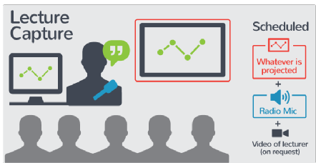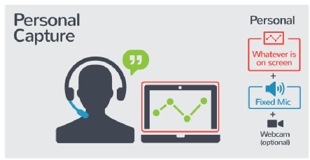
The majority of recordings on the echo360 system are through the auto-scheduled lecture capture method.
Only sessions in rooms equipped with the echo360 device can be auto-scheduled. Currently large teaching rooms and lecture theatres are equipped with the echo360 device. The auto-scheduled lecture capture method can be set up in advance, and for the whole module.
The majority of the auto-scheduled lecture captures are screen and audio only. Video is only switched on for a session recording on request.
The main thing for presenters to remember in equipped rooms is to wear the radio mic and ensure it is switched on. With the radio mic it is possible for presenters to leave the lectern and move about.
It is possible to train the camera on a chalkboard, on request. It is possible to include the visualizer in the recording when it is displayed on the main screen.
Students do not expect recordings to be edited, they are happy to scroll to the start.
The auto-scheduled method is not intended for editing and creation of high production value videos. It is designed to record what is delivered from the front, at scale and in a sustainable and supported way.
It is possible that lecture “capture” is an unhelpful term as it implies more than it needs to: members suggested that lecture recording is more accurate.
Discussion is generally not captured well by the presenter’s radio mics, but students do not expect discussions to be captured. It is reasonable to switch off the radio mic during discussions if the academic and students prefer not to capture it.
For sessions in non-equipped rooms, the personal capture software can be used. There are also other methods of recording
ACTION: Jon Owen to share some data/analytics on echo360 use with the group

Perspectives

Benefits to Students
As the Student Union describes,
“There are so many different reasons why lectures should be recorded:
- The ability to listen again if you miss the bus, if you’re ill, or can’t make the lecture because of a sports fixture.
- Helpful for students from whose first language is not English to listen again.
- Allows students to concentrate on the lecture and make better notes.
- Lecture recordings are reasonable adjustment for disabled students to help with their studies.”
See http://www.warwicksu.com/campaigning/campaigns/education/recordedlectures/

Staff anxieties about recording
There are anxieties about being recorded. This may be particularly where material is new and/or research-oriented. Students are not expecting a polished performance, and there is no evidence that they only value the charismatic lecturer. Academics report that they get more comfortable with recording as time goes on, so it may be that there is an adoption discomfort that is overcome with time.

Attendance
There are anxieties about lecture capture affecting attendance but there is not evidence that this is the case. In two departments (Physics and WMG) the question has been investigated at small scale, and have that the scheduling of the lecture affects attendance: early mornings and Wednesday afternoons reduce attendance, and it is also possible that there is a traditional general dropping off of attendance in many modules but that it has not been formally tracked before. Lecture capture is not being promoted as a substitute for attendance: it is a supplement. That said, it is useful as a safety net for when student is unable to attend due to illness, work commitments or travel problems.

Disability and Inclusion
There are specific benefits to students with visual or aural disabilities, cognitive conditions such as dyslexia, or students for whom a packed timetable is challenging, for reasons of mobility (wheelchair users) or pace (autistic spectrum), and for students with English as a second language. For all these reasons it can be useful to watch/listen to recordings again.
There may be circumstances where a student requests livestreaming as a reasonable adjustment. This group may want to take a position on livestreaming.
If a student requests lecture recording as a reasonable adjustment then the University has a duty to meet that request unless there are very good reasons to. BIS clearly states in its statements on the withdrawal of Disabled Student Allowance that it expects Universities to invest in lecture capture solutions.
ACTION: Steve Luci Matthews to report to staff disability group this afternoon that this group is underway, so that we can follow up

Identify decisions to be made

The group was provided with a framework for the overall policy.
Particular attention needs to be given to:
- Access – for who and for how long
- Taking a position on live streaming
- Providing more clarity on copyright
- How to strengthen the mandate for reasonable adjustments

ACTION: Amber Thomas to draft notes for circulation

Draft agenda for next meeting: TBC

Next meeting: MTG2 Monday 23rd May, 2.00 – 3.00 venue CMR0.3 UH.

